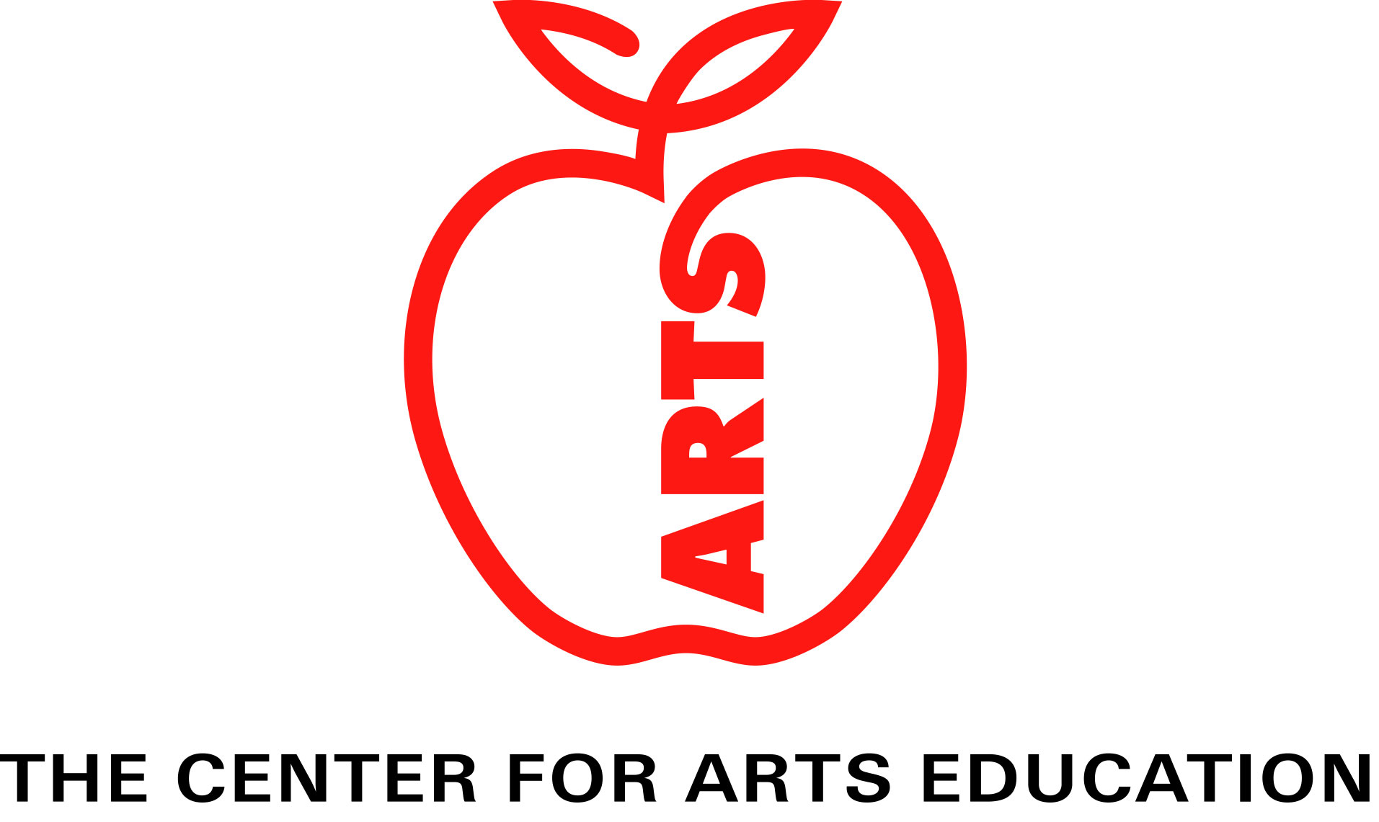

www.cae-nyc.org

PROJECT ARTS AND THE NEED TO SUSTAIN FUNDING and SUPPORT FOR ARTS EDUCATION

Briefing Document

March 2007

“If we don’t give our children exposure to the arts,
this city doesn’t have a future.”- Mayor Michael R. Bloomberg

The Center for Arts Education (CAE) is committed to restoring, stimulating, and sustaining quality arts education as an essential part of every child’s education. We create, identify, fund, and support exemplary partnerships and programs that demonstrate how the arts contribute to learning and student achievement.

CONTACTS: Richard Kessler, Executive Director
Richard@cae-nyc.org, 212-971-3300 ext. 303

Heather Mangrum, Director of Marketing and Public Relations
Heather@cae-nyc.org, 212-971-3300 ext. 308

Background

WHAT IS PROJECT ARTS?
Project ARTS (Arts Restoration to the Schools) was introduced in 1997 by Mayor Rudolph Giuliani in response to the dire lack of arts education in New York City public schools and the need for restoration. He created a budget line committing $25 million per year over three years with the goal of gradually rebuilding comprehensive arts education system-wide. Shortly after its creation, Project ARTS was increased to $75 million per year.

Project ARTS was created with the understanding that arts education needed to be incentivised through dedicated funding. The arts have been positioned as the equivalent of a “protected class,” since the New York City public school system had been at variance with even the most minimal state requirements, did not employ nearly enough arts teachers, was suffering under the narrowing of the curriculum, and was slow to gain ground with administrators who often had little first hand knowledge or training in arts education.

For the current school year, Project ARTS funding is $67.5 million and is equivalent to an arts education safety net for many of our students. More than any other single event or initiative, Project ARTS has been the catalyst for the growth and expansion of arts education over the past ten years.

PROJECT ARTS AT RISK
As part of the Children First school reform initiative, the New York City Department of Education has proposed the elimination of Project ARTS as a categorical funding line, the elimination of the Regional Arts Supervisors, as the regions are being eliminated, and consequently the elimination of the school-based Project ARTS Liaisons. Instead, spending on arts education will be completely at the discretion of individual school principals whose performance and efficacy will be judged overwhelmingly on how well their school does on the new School Progress Report. The DOE’s position is that principals will be held accountable through the new Accountability Initiative for ensuring an adequate arts program in each school.

School Progress Report (aka “School Report Card”), which will assign a single grade – “A” through “F” – for each school using the following formula:
  - School Environment = 15%
  - Student Performance = 30%
  - Student Progress = 55%
  - Closing the Achievement Gap = additional credit

The Accountability Initiative will address the arts in two ways:
- A few questions in the School Environment section of the annual School Progress Report.
- As part of the Quality Review, currently being conducted by Cambridge Consultants.

The School Environment section accounts for 15% of the total school grade on the School Progress Report. It is to be modeled on customer satisfaction surveys and is for select teachers, parents, and students. In addition, this section looks at overall attendance. This is the section that references the arts: there will be a few questions on the survey to parents, teachers, and students about arts education in each school.

The Student Performance and Student Progress sections comprise 85% of the School Progress Report and are based on standardized tests in reading and mathematics.

The Quality Review is conducted on-site by teams of reviewers external to the school and can last up to three days. It does consider a school’s arts offering and concludes with an overall score of “Well Developed,” “Proficient,” or “Undeveloped.” The Quality Review will consider the quality of arts education in each school. However, the Quality Review does not influence the grade score a school receives on the School Progress Report.

A performance incentive program (Rewards and Consequences) is tied to the total score. While the Quality Review score does not count towards the grade a school receives on the School Progress Report, it is used in determining what “rewards and consequences” (a DOE term) will result from that score: financial rewards for schools scoring “A” (unless they have a low score on the Quality Review); or target-setting school improvement measures, and possible leadership changes, restructuring, or closure, for schools with scores of “D” or “F.”

Other Proposed Initiatives

The DOE will create an Annual Arts in School Report, published for “parents, principals, and students,” which will provide participation data, school spending data, details from quality review report and student and parent survey (School Environment); and an Annual Arts Survey, including questions on arts offerings by discipline, use and satisfaction of arts partners, facilities needs, etc., and results of analysis of correlation between student and school outcomes and arts participation. (This report should be a significant tool in understanding the system from year to year.)

KEY ISSUES EXAMINED

Elimination of Project ARTS
DOE Proposal
Eliminate Project ARTS as a categorical line of funding.

CAE Position
Project ARTS is a critical source of funding for arts teacher salaries, services of cultural and community-based organizations, arts supplies and professional development for classroom teachers.

Argument: Sustaining this fiscal resource for at least an additional year will help seed spending for arts education across the system during this major period of transition. This would create a stronger comparison from baseline to the end of the next school year, as well as provide time to develop performance-based assessments.

The arch of time for the Chancellor’s plan to take effect is an entire academic year. If problems emerge, which is to be expected based on prior history of unrestricting Project ARTS funds*, little can be done until the following year, as school budgets will already be set for an entire academic year. If the funding is eliminated immediately and, after one year, the chancellor chose to restore the funding, the damage would already be done and would most likely prove very difficult to remedy. It may also be very difficult to establish that cutbacks are specifically due to the elimination of Project ARTS. For example, should a principal decide to cut an arts teacher position that was being funded at 50% of salary by Project ARTS, how would you determine that the cut was due to the elimination of Project ARTS?

In addition, in order for the Accountability Initiative to truly counterbalance against cuts to arts funding resulting from the elimination of Project ARTS, the development and inclusion of performance-based assessments would need to be in place so the arts could be a real part of The School Progress Report: the Student Performance and Student Progress sections. The DOE acknowledges that these sections do not yet include the arts and that they are willing to incorporate the arts when appropriate assessments are developed.

Finally, much of the Accountability Initiative will not begin to have a practical effect until the end of the 2007-2008 academic year, as that will be the first period of comparison available between the baseline data created at the end of 2006-2007 and the next year.

* In 2001, Chancellor Levy reduced the allocation for Project ARTS from $75 to $52 million and gave district superintendents permission to re-direct Project ARTS resources to cover expenses other than arts instruction, supplies and the services of cultural organizations. The result was a 50% reduction in arts education spending.

Recommended Action
Continue Project ARTS at least through the 2007-2008 school year.

The Arts and the Accountability Initiative
DOE Proposal
The new Accountability Initiative will hold Principals accountable for adequate levels of arts education in each school (see previous section).

CAE Position
The bulk (85%) of the Accountability Initiative is based upon standardized testing in English Language Arts and Math.

Argument: This is not an accurate reflection of a school’s success. A complete, well rounded education includes many other important elements – communication skills, creativity, critical thinking, how to work collaboratively. In the School Progress Report more qualitative measurements found in the School Environment section only account for 15% of the entire grade. Of that 15%, the arts are expected to be a minor portion of the survey.

In addition, the Quality Review does not factor as part of the grade given a school, only as part of determining the “rewards and consequences” (a DOE term): financial rewards for schools scoring “A” (unless they have a low score on the Quality Review); or target-setting school improvement measures, and possible leadership changes, restructuring, or closure, for schools with scores of “D” or “F.”

The proposed Annual Arts Survey, in which parents can grade the effectiveness of cultural partners and classroom arts offerings, could be a vital tool in understanding and tracking arts education from school to school and in the system, but has no real impact on the Accountability Initiative.

Recommended Action
Increase the degree to which the arts are reflected in the most significant portion of the Accountability Initiative, so that arts education is protected by the “rewards and consequences” lever of the Accountability Initiative.

increasing Arts Education Funding

DOE Proposal
Instead of replacing Project ARTS funding, make arts education funding across the system based in general operating budgets at the discretion of individual principals.

CAE Position
An increase in minimum spent for arts education by principals, combined with the improvements gained through the Accountability Initiative, could go a long way to helping the New York City Department of Education finally meet the minimum New York State requirements in the arts.

Argument: With the emergence of The Campaign for Fiscal Equity lawsuit settlement and the increase in spending for New York City public schools proposed by Governor Spitzer, the NYCDOE is expected to see an increase to its annual budget of over 30%. Project ARTS should receive a similar increase to $100 million annually, from the current $67.5 million. With a system that is still far away from meeting the most minimal state requirements in arts education, the time is now to provide even greater resources to ensure equity and quality in arts education instruction for all New York City public school students.

Recommended Action
Increase Project ARTS funding to $100 million.

The Arts As A Protected Category In Education
DOE Proposal
Eliminate all forms of categorical funding in New York City public education within the power of NYCDOE

CAE Position
Until NYCDOE can find ways to comply with minimum State requirements in arts education, the arts must remain a protected category.

Argument: Project ARTS was initially not part of the DOE budget, but was rather a separate funding line created by then Mayor Giuliani. Therefore, if the DOE is intent on eliminating all categorical funding under its purview, Project ARTS could be administered outside of the school budget, as it was originally established. It is understandable that Project ARTS is in conflict with the intent of the new Children First Reforms to empower the principals by giving them as much control of their schools and school budgets as possible. To avoid this conflict, Project ARTS could be administered outside of the DOE, by the DCA, or another organization, and even be renamed if necessary.

It is said that reading and math do not have earmarks, however, the vast majority of testing, instructional time, and budget goes to support these two subjects at the expense of arts education, which only reinforces the reasons for categorical funding of arts education.

Recommended Action
Administer Project ARTS through the Mayor’s operational budget until the system finds a way to meet and sustain the minimum New York State requirements.

Regional Arts Supervisors
DOE Proposal
Eliminate the Regional Arts Supervisors as the Regions are being eliminated and allow the three different support structures to determine if and how they will support the arts on a supervisory level.

CAE Position
The Regional Arts Supervisors have played a critical role in supporting arts education within the Regions and represent a critical body of knowledge and experience in supporting and implementing arts education at the school level.

Argument: While great strides have been made in the past few years, particularly in regards to Blueprint training for arts specialists, The New York City public school system has been historically week in terms of providing professional development and information on arts education for its principals and assistant principals. With these new structures and the increasing autonomy given to principals, support will be critical in identifying and implementing appropriate arts programs and partners according the needs of each school. These supervisors can also help individual schools share resources and best practices, which could result in cost savings.

Recommended Action
Shift the role of Regional Arts Supervisors to work directly with Learning Support Organizations, Partnership Support Organizations and Empowerment Schools.

PROFESSIONAL DEVELOPMENT IN ARTS LEARNING
DOE Proposal
Give principals sole discretion in making decisions on arts learning for their schools

CAE Position
In order for principals to understand fully the value of arts education and how to incorporate it in the teaching and learning in their schools, they must have adequate professional learning in arts education.

Argument: Since its inception, the Leadership Academy, a program of the NYCDOE, which develops new principals and assistant principals, has little in its curriculum related to arts education. Principals often have little background in arts education, having had little during their K-12 education and none during their pre-service training to become teachers. Without 1500 principals and a strong number of assistant principals that are knowledgeable about arts education, giving complete autonomy to these principals around arts education makes little sense.

Recommended Action
Include Arts Education in the Curriculum of the Leadership Academy, and work with the arts education community to build a significant program to develop the necessary skills of principals and assistant principals.

THE EFFECTIVENESS OF PROJECT ARTS
DOE Proposal
That it has not been effective in ensuring arts education for all students and that it serves as both a floor and a ceiling for arts education.

CAE Position
Not enough information exists about Project ARTS to serve as the basis for a decision to eliminate it based on its efficacy.

Argument: Project ARTS was designed as a safety net, helping to secure a minimum level of arts education, while being a catalyst for the hiring of certified arts teachers, the purchasing of supplies, securing the services of arts education providers, and encouraging the contribution of private funds to match public dollars. While everyone agrees that it needs improvement and redesign, only through a significant independent study of Project ARTS can reasonable conclusions be made as the basis for such a redesign.

RECOMMENDED ACTION
Continue Project ARTS at least another year and commission a major study on its efficacy, as well as recommendations for its future.

*Key data to keep in mind about Arts Education and the New York City Public Schools:
- Number of full-time arts specialists (all disciplines): 2,015
- Number of part-time arts specialists: 288
- Schools without any full or part-time arts specialists: at least 268
- Over 60% of schools report not having at least one partnership with an arts organization that provides direct instruction to students
- The New York City Department of Education is not meeting the minimum New York State requirements for arts education.

